Muhammad Sherjeel Akhtar
20p-0101
BCS: 5A

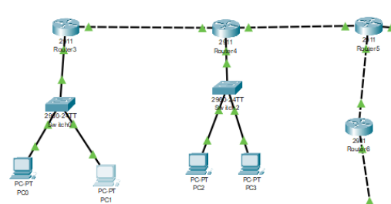
.
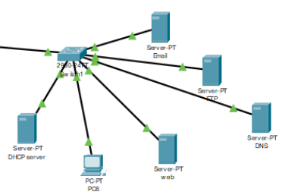
.

.
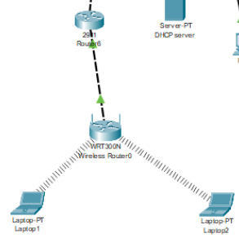
.

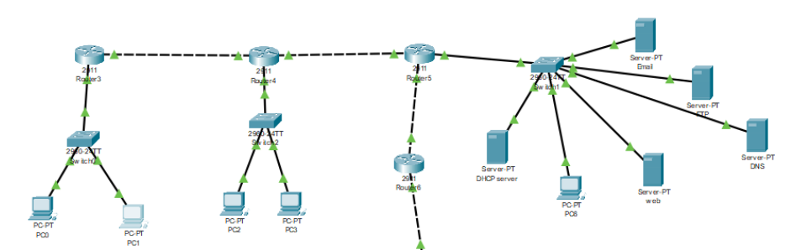
.
Config:
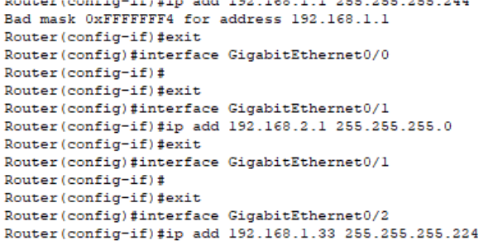
.
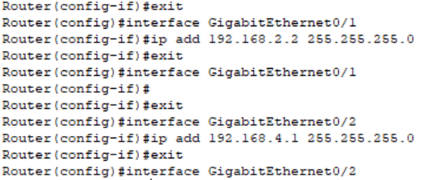
.
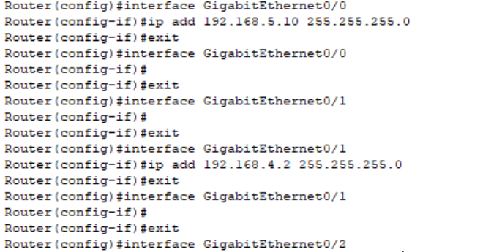
.
Wireless Router:
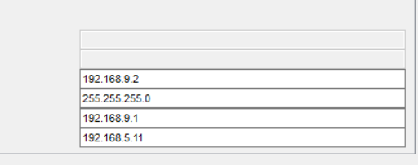
.
LAN Settings:
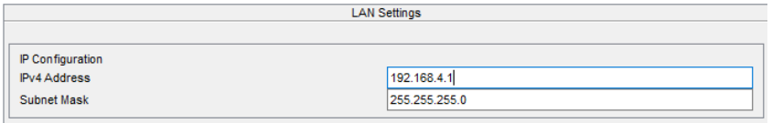
.
.Router-3 Configuration:
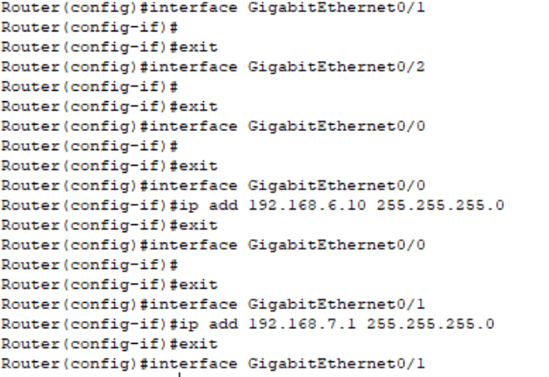
.
Server Configuration:
Email:
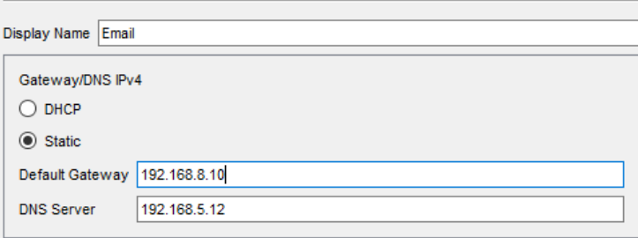
.
Email Server IP Configuration:
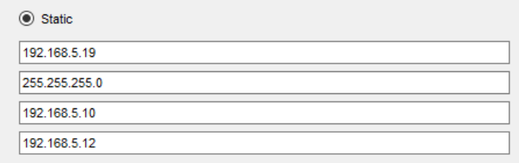
.
Outgoing And Incomming Mail Server:
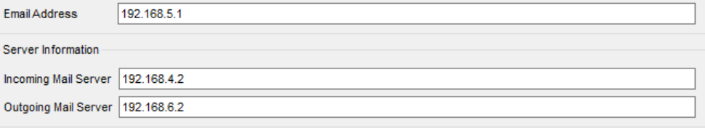
.
FTP Server Configuration:

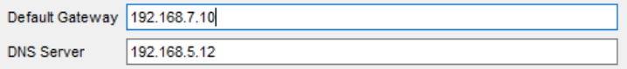
.
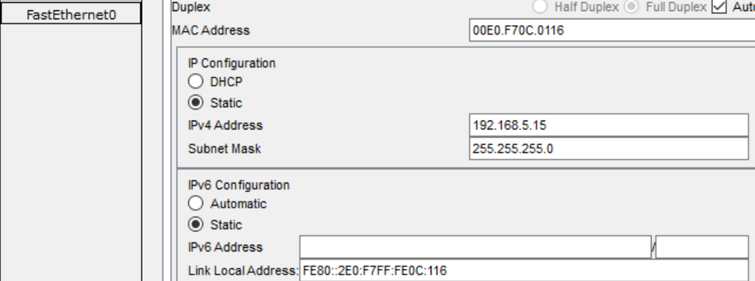
.
FTP IP Configuration:
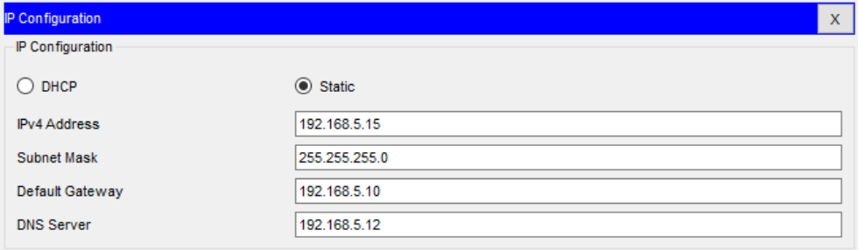
.
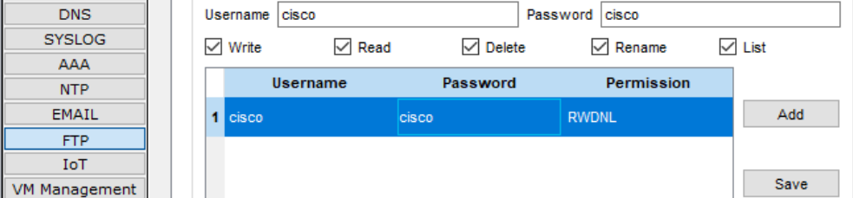
.
DNS Server Configuration:
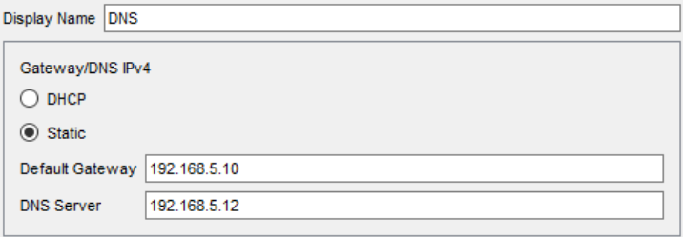
.
IP Configuration:
.
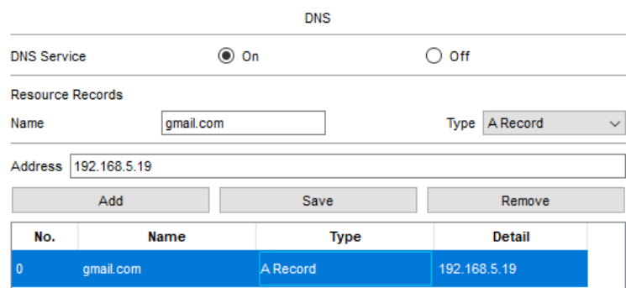
.
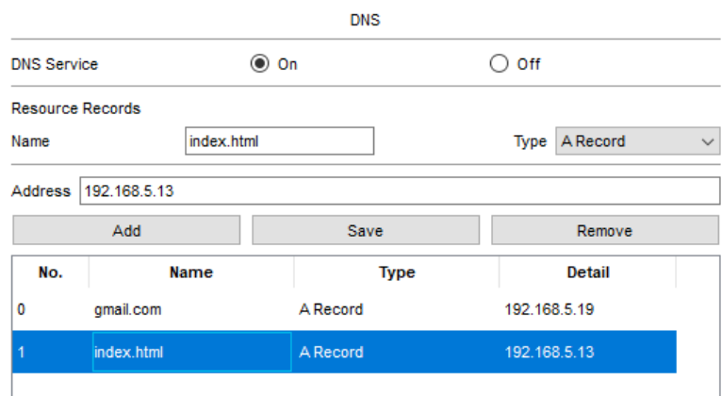
.
DNS IP Configuration:
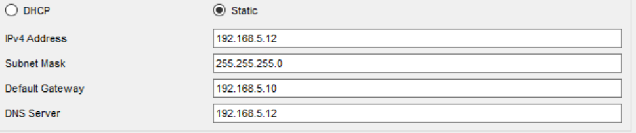
.
Web Server Configuration:
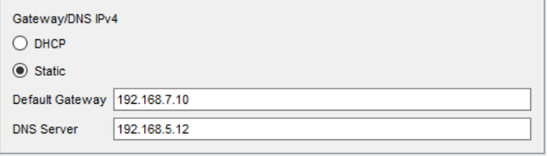
.
IP Configuration:
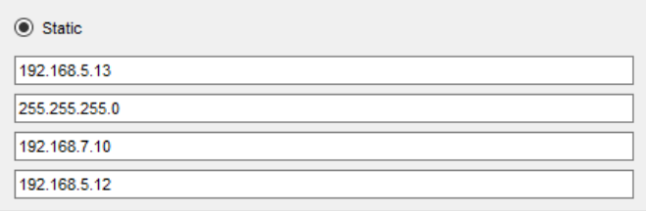
.
HTTP Configuration:
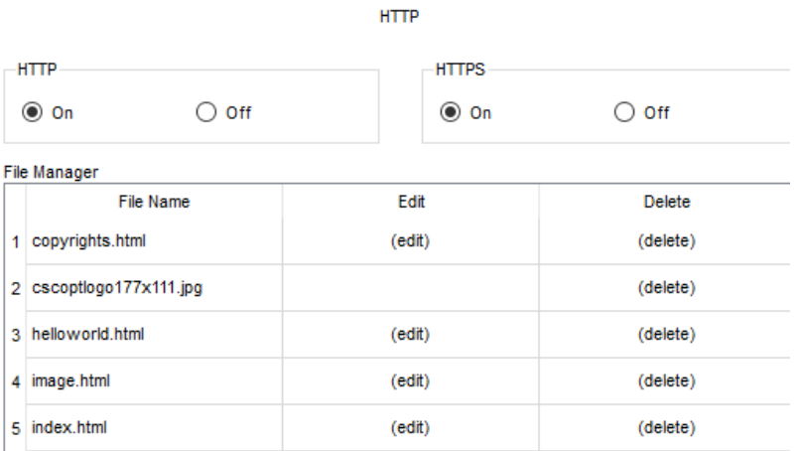
.
Addition In Web Server:
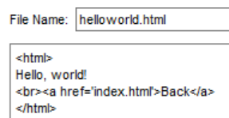
.

.

DHCP Server Configuration:
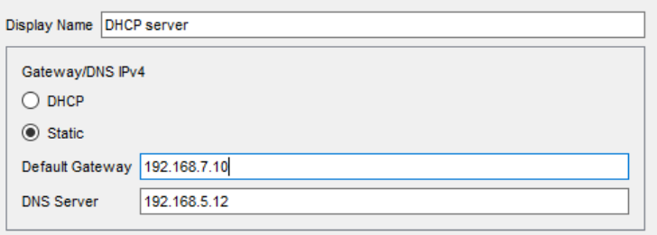
.
IP Configuration:

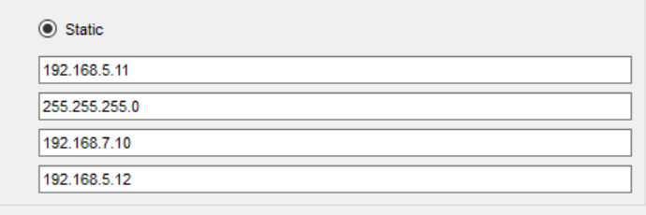
.
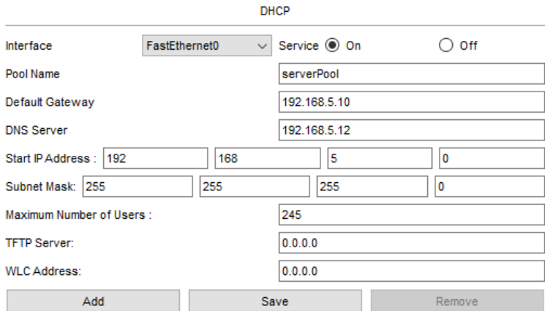
.
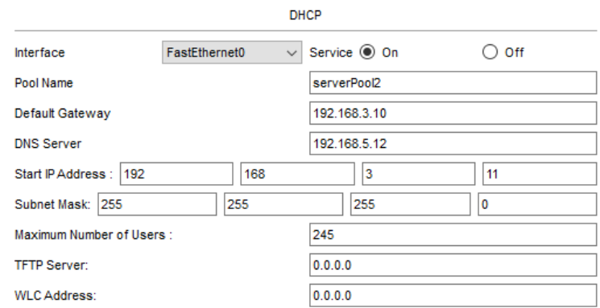
.
POOL 3:
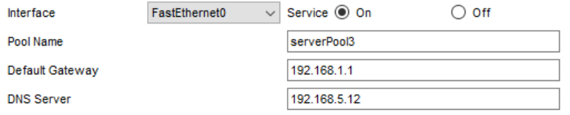
.
POOL 4:
.
POOL 5:
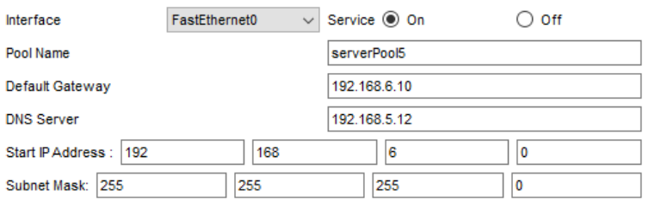
.
DHCP IP Assignment:
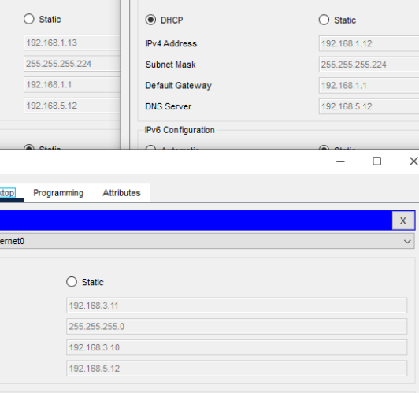
.
Conclusion:
You will receive a response after visiting the site.
-------------------------------

